**Aim:- To implement various DDL,DML commands and constraints.**

**THEORY:**

**DDL(Data Definition Language):** DDL or Data Definition Language actually consists of the SQL commands that can be used to define the database schema. It simply deals with descriptions of the database schema and is used to create and modify the structure of database objects in database. Examples of DDL commands:

* **CREATE** – is used to create the database or its objects (like table, index, function, views, store procedure and triggers).
* **DROP** – is used to delete objects from the database.
* **ALTER**-is used to alter the structure of the database.
* **TRUNCATE**–is used to remove all records from a table, including all spaces allocated for the records are removed.
* **COMMENT** –is used to add comments to the data dictionary.
* **RENAME** –is used to rename an object existing in the database.

**DML(Data Manipulation Language):** The SQL commands that deals with the manipulation of data present in database belong to DML or Data Manipulation Language and this includes most of the SQL statements. Examples of DML:

* **SELECT** – is used to retrieve data from the a database.
* **INSERT** – is used to insert data into a table.
* **UPDATE** – is used to update existing data within a table.
* **DELETE** – is used to delete records from a database table.

**SQL constraints**: It are used to specify rules for the data in a table. Constraints are used to limit the type of data that can go into a table. This ensures the accuracy and reliability of the data in the table. If there is any violation between the constraint and the data action, the action is aborted. Constraints can be column level or table level. Column level constraints apply to a column, and table level constraints apply to the whole table. The following constraints are commonly used in SQL:

* **NOT NULL** - Ensures that a column cannot have a NULL value
* **UNIQUE** - Ensures that all values in a column are different
* **PRIMARY KEY** - A combination of a NOT NULL and UNIQUE. Uniquely identifies each row in a table
* **FOREIGN KEY** - Uniquely identifies a row/record in another table
* **CHECK** - Ensures that all values in a column satisfies a specific condition
* **DEFAULT** - Sets a default value for a column when no value is specified

1. **DDL(Data Definition Language):**
2. **CREATE:**

**SOURCE CODE:**

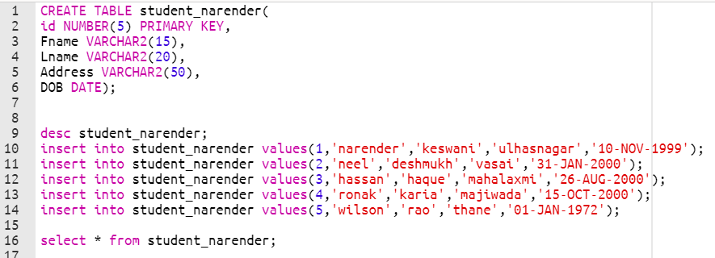

**OUTPUT:**

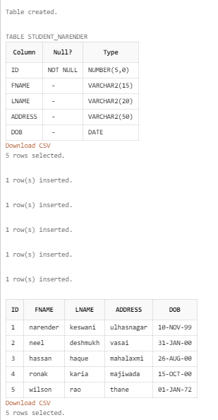

1. **DROP:**

**SOURCE CODE:**



**OUTPUT:**



1. **ALTER:**

**SOURCE CODE:**



**OUTPUT:**

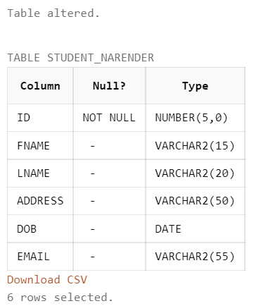

1. **TRUNCATE:**

**SOURCE CODE:**



**OUTPUT:**



1. **RENAME:**

**SOURCE CODE:**



**OUTPUT:**



1. **DML(Data Manipulation Language):**
2. **SELECT:**

**SOURCE CODE:**



**OUTPUT:**

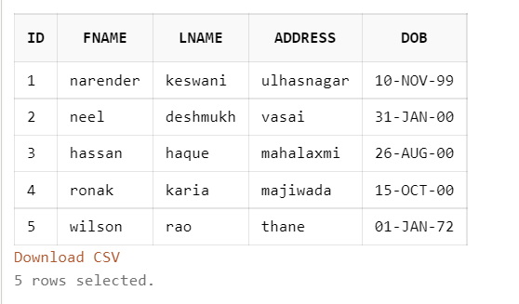

1. **INSERT:**

**SOURCE CODE:**

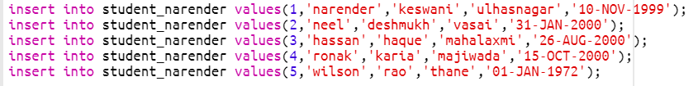

**OUTPUT:**

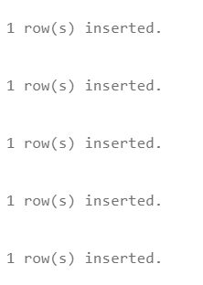

1. **UPDATE:**

**SOURCE CODE:**



**OUTPUT:**



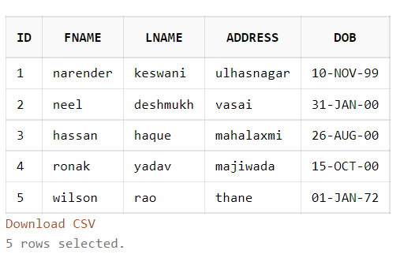

1. **DELETE:**

**SOURCE CODE:**



**OUTPUT:**



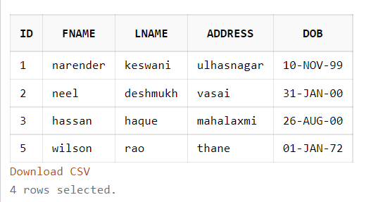

1. **SQL constraints:**
2. **PRIMARY KEY:**

**SOURCE CODE:**



**OUTPUT:**



1. **FOREIGN KEY:**

**SOURCE CODE:**

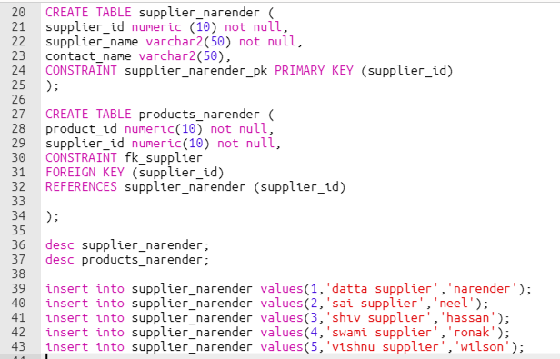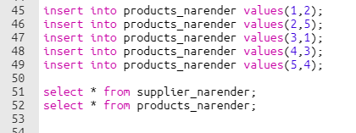

**OUTPUT:**

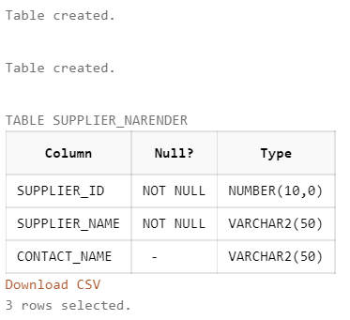

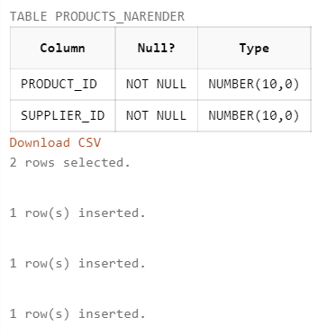

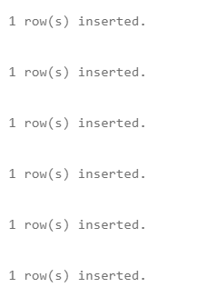

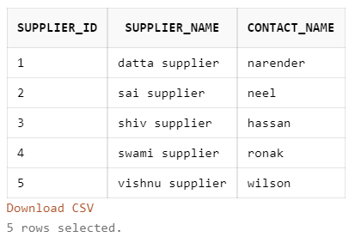

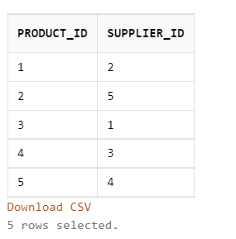

1. **UNIQUE CONSTRAINT:**

**SOURCE CODE:**

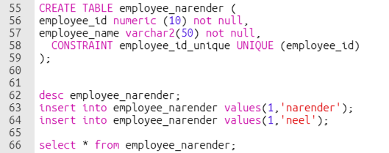

**OUTPUT:**

Unique Constraint is used to set unique value of the particular field

In this example, the e_id is set as unique value

If same value of e_id is inserted again then it will create an error.

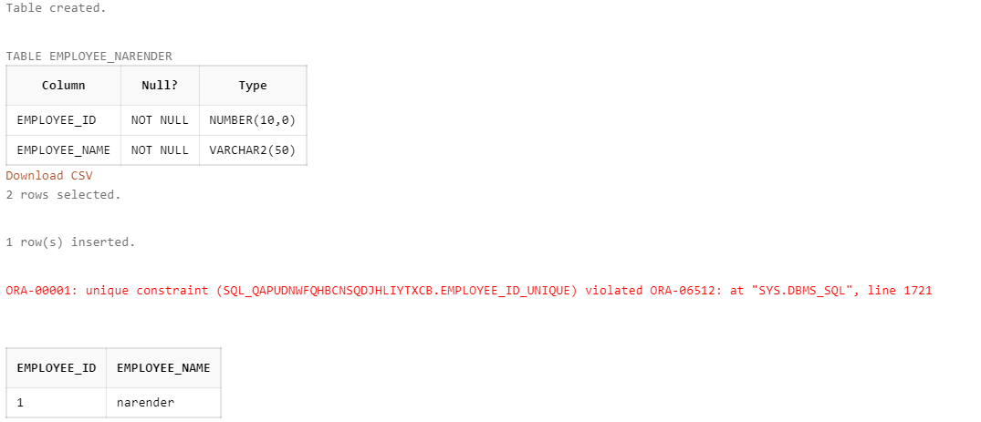

1. **DEFAULT CONSTRAINT:**

**SOURCE CODE:**

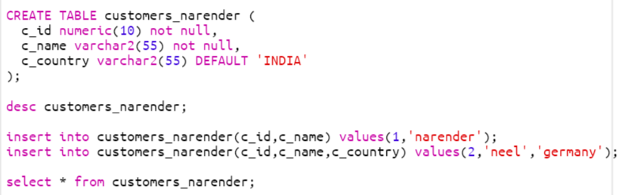

**OUTPUT:**

Default constraint is used to set the default value for particular field.

In this example, the c_country is set to the default value of ‘INDIA’

If we do not specify the value of the c_country then the default value will be ‘INDIA’.

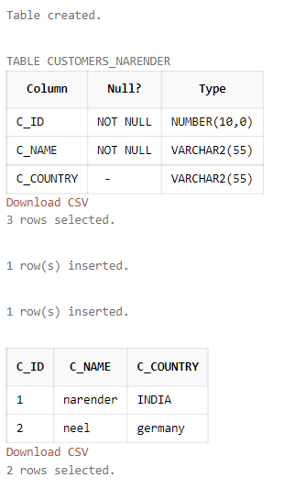

1. **CHECK CONSTRAINT:**

**SOURCE CODE:**

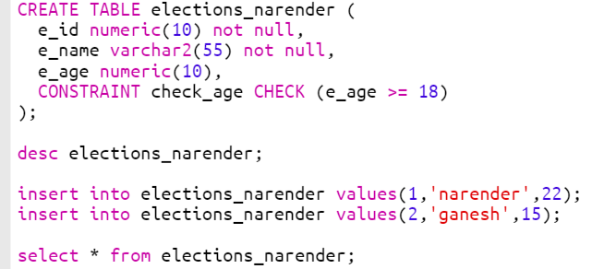

**OUTPUT:**

The check constraint is used to check the condition

If the condition is true then only allow to insert the values, else it will throw error.

In this example, we have checked the age of person who are eligible for voting

So, if the person’s age is less than 18 them it will not insert the value in the table.

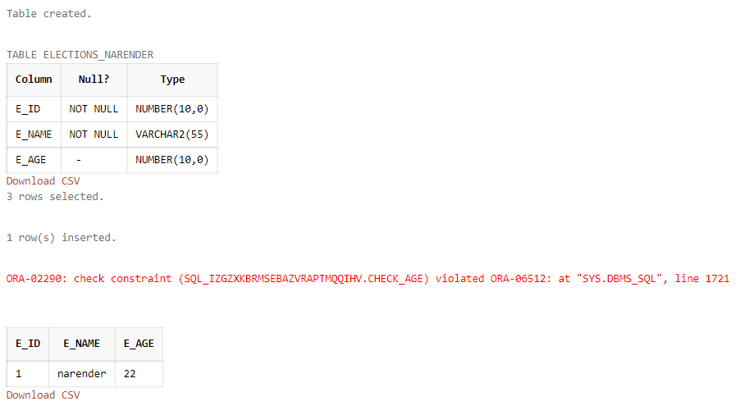

1. **NOT NULL:**

**SOURCE CODE:**

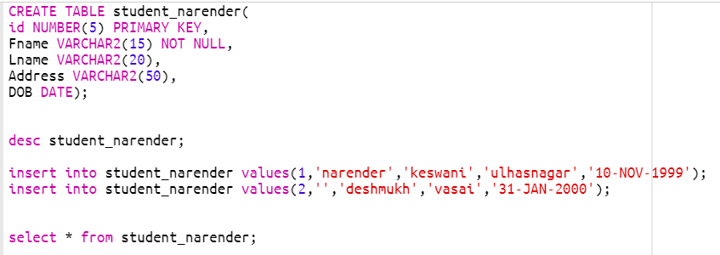

**OUTPUT:**

If we do not pass the value in the not null field, it will throw the error.

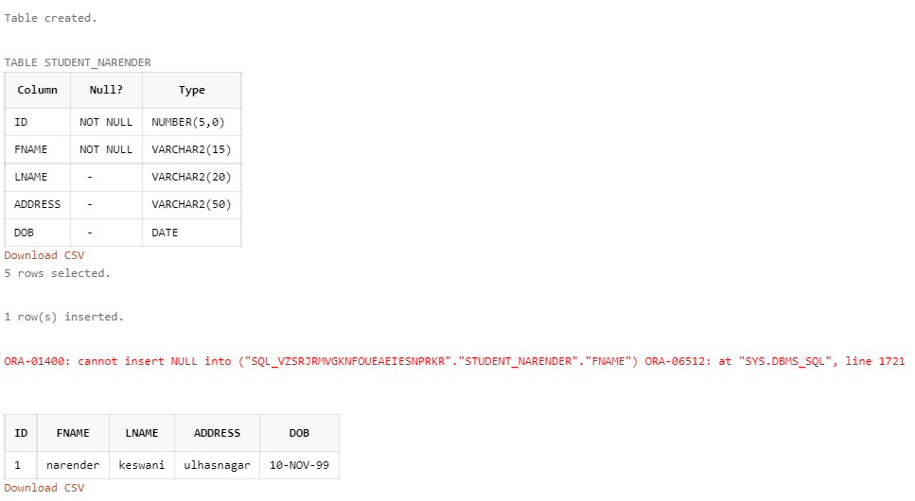

**CONCLUSION:**

I have learned the basics of DML, DDL, SQL Constraints from this assignment/tutorial.